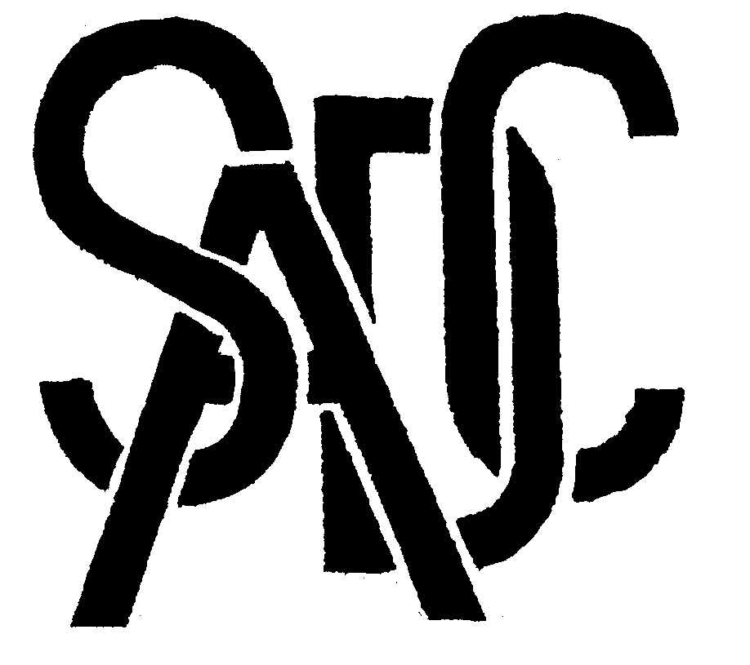

Southern African Development Community (SADC) Cooperation in Measurement Traceability
Angola, Botswana, Democratic Republic of Congo, Lesotho, Malawi, Mauritius, Mozambique, Namibia, Seychelles,
South Africa, Swaziland, Tanzania, Zambia, Zimbabwe

The Director
Tanzania Bureau of Standards (TBS)
P.O. Box 9524
Dar es Salaam
Tanzania 1 August 2005

SADCMET WATER TESTING PROFICIENCY SCHEME: EVALUATION WORKSHOP AND UNCERTAINTY COURSE, 6-11 November 2005

Dear Mr Mwakyembe
You will recall that SADCMET, with the support of PTB, has been running a proficiency scheme for water testing labs for its members since last year.

We have now just embarked on round 2 of the Scheme, which we hope to complete by October of this year. We intend to hold an evaluation workshop to analyse the findings and at the same time to run an intensive 5 day training course on measurement uncertainty for chemical laboratory staff.

Having been informed by my colleague Franz on the progress that the TBS chemical lab is making in preparation for its accreditation next year, I thought that your lab might offer interesting lessons for other similar labs in the region. In this regard, would it be feasible for TBS to host our forthcoming PT Workshop/Training session that we have scheduled for the week of 6-11 November 2005.

PTB will be funding the Workshop (accommodation, flights, allowances) and the only requirements we would request from TBS would be in the form of local logistics; recommending a suitable local hotel; lab visits; arranging for visits to water treatment plants; an evening function for the delegates etc.

I look forward to hearing from you. Please do not hesitate to contact me for any further clarifications and details you might require

Warm regards

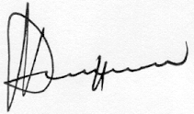
Dr M.T. Musarurwa
Regional Co-ordinator: SADCMET
CSIR-National Metrology Laboratory
Pretoria, South Africa
e-mail: mmusarurwa@csir.co.za
Tel. 27-12 841 3898
Fax 27-12 841 2131

